|  |  |  |  |
| --- | --- | --- | --- |
| Title: **Angle Bracket** | | Position/s: Pb, (Horizontal vertical) | |
| Weld Process: MMA/MAG/TIG | DWG Scale: 1:2 | Electrode Type: Rutile 6013,Basic 7018,Thoriated Tungsten, 1mm CCMS | All measurements in mm |
| Material: Flat Black Bar (Mild Steel) | Material Thickness: 5mm | Linear Alignment: ± 3mm | Revised Date: 09/05/2016 |

**LEVEL TWO WELDING**

   

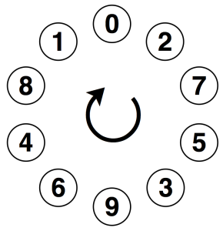



**Single sided Fillet weld, Pb position.**

**Multi Run Fillet (3 Passes), 40mm long, Pb position.**

**Single sided Fillet weld, Pf position.**

**Side of Pf and Pb positioned welds.**

**(40)**







**3**

60

100

220

45°

5

200

100

47.5

155

5

60

165

230

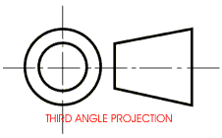

REMOVE ALL BURRS, VISABLE SLAG & SPATTER