|  |  |  |  |
| --- | --- | --- | --- |
| Title: **‘Knocking Block’ Level 1 Comp’** | | Position/s: Pa ((Flat hand down) Pb, (Horizontal vertical) | |
| Weld Process: TIG | DWG Scale: 1:1 | Electrode Type: Thoriated (RED) | All measurements in mm |
| Material: Flat Black Bar (Mild Steel) | Material Thickness: 5mm | Linear Alignment: ± 3mm | Revised Date: 10/05/2016 |

REMOVE ALL BURRS

**LEVEL ONE TIG WELDING**

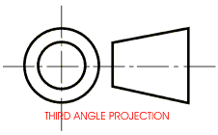

50

25

25

5

30

50

65

150

150

**Note:**

**Welds can be carried out in either autogenic or rod fill.**

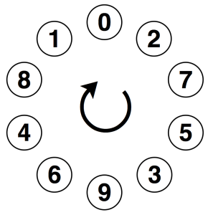**Single sided Fillet weld, Pb position.**

 **Outside Corner (flush corner) Pa position.**

   

5

5

5

50

5









