|  |  |  |  |
| --- | --- | --- | --- |
| Title:**‘Knocking Block’ Level 1 Comp’** | | Position/s:Pb, (Horizontal vertical) | |
| Weld Process: MMA/MAG | DWG Scale: 1:1 | Electrode Type: Rutile 6013,  1mm CCMS | All measurements in mm |
| Material: Flat Black Bar (Mild Steel) | Material Thickness: 5mm | Linear Alignment:± 3mm | Revised Date: 03/05/2016 |

**LEVEL ONE MAG & MMA WELDING**

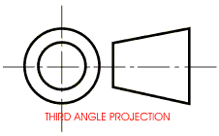

5

REMOVE ALLBURRS, VISABLE SLAG& SPATTER

5

50

25

5

25

5

30

50

65

150

50

5

160



**Note:**

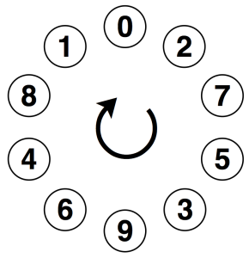**Single sided Fillet weld, Pb position.**

**Outside Corner (full open corner)Pa position.**









